Project Planning Phase
Project Planning Template (Product Backlog, Sprint Planning, Stories, Story points)

Date | 18 October 2026
Team ID | EN25CS3010360
Project Name | Global Olympic Sports Performance Analysis
Maximum Marks | 8 Marks

Product Backlog, Sprint Schedule, and Estimation (4 Marks)
Use the below template to create product backlog and sprint schedule
Sprint | Functional Requirement (Epic) | User Story Number | User Story / Task | Story Points | Priority | Team Members
Sprint-1 | Data Preparation | US-1 | As an analyst, I can load the Olympic medal summary CSV so the dashboard has a data source. | 3 | High | Project team
Sprint-1 | Data Preparation | US-2 | As an analyst, I can check and prepare country, medal, season, and year fields for analysis. | 5 | High | Project team
Sprint-1 | Country Analysis | US-3 | As a viewer, I can see the top 10 countries by medal count. | 3 | High | Project team
Sprint-1 | Medal Comparison | US-4 | As a viewer, I can compare Gold, Silver, and Bronze medals across countries. | 3 | High | Project team
Sprint-2 | Season Analysis | US-5 | As a viewer, I can compare Olympic performance in Summer and Winter Games. | 3 | High | Project team
Sprint-2 | Trend Analysis | US-6 | As a viewer, I can explore Olympic medal trends over time. | 5 | High | Project team
Sprint-2 | Dashboard Filter | US-7 | As a viewer, I can filter the dashboard by country to focus on selected results. | 3 | Medium | Project team
Sprint-2 | Dashboard Design | US-8 | As a viewer, I can use a clear, consistent dashboard layout with readable titles and labels. | 3 | Medium | Project team
Sprint-3

Project Tracker, Velocity & Burndown Chart: (4 Marks)
Sprint | Total Story Points | Duration | Sprint Start Date | Sprint End Date (Planned) | Story Points Completed (as on Planned End Date) | Sprint Release Date (Actual)
Sprint-1 | 14 | 6 days | 27 Oct 2026 | 01 Nov 2026 | Not yet measured | Pending
Sprint-2 | 14 | 6 days | 03 Nov 2026 | 08 Nov 2026 | Not yet measured | Pending
Sprint-3 | 3 | 3 days | 10 Nov 2026 | 12 Nov 2026 | Not yet measured | Pending

Velocity:
Planning estimate: total estimated backlog = 31 story points across three sprints. Since no actual sprint completion data was provided, velocity and burndown are planning estimates only, not measured team performance.
Assumed planning velocity: 14 story points per 6-day sprint (about 2.33 story points/day). Actual velocity should be recalculated from completed story points after each sprint.

Burndown Chart:
A burn down chart is a graphical representation of work left to do versus time. It is often used in agile software development methodologies such as Scrum. However, burn down charts can be applied to any project containing measurable progress over time.
Illustrative Sprint 1 burndown (ideal line; update with actual daily progress):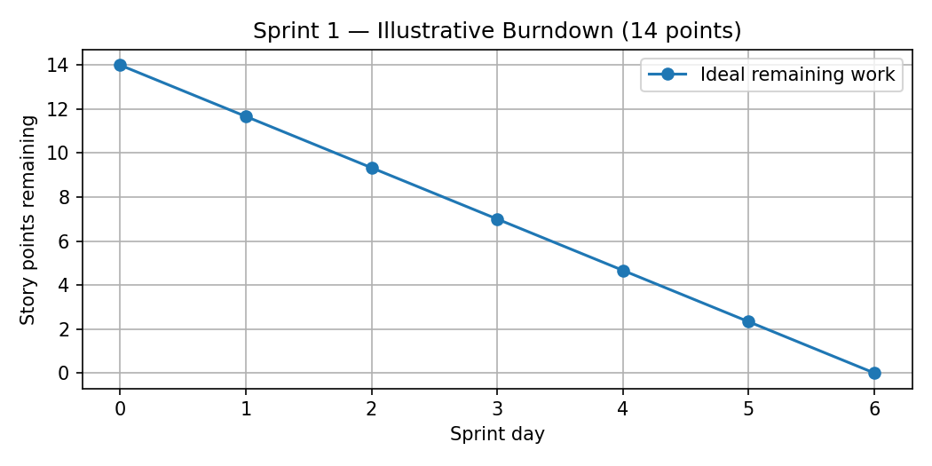

https://www.visual-paradigm.com/scrum/scrum-burndown-chart/
https://www.atlassian.com/agile/tutorials/burndown-charts

Reference:
https://www.atlassian.com/agile/project-management
https://www.atlassian.com/agile/tutorials/how-to-do-scrum-with-jira-software
https://www.atlassian.com/agile/tutorials/epics
https://www.atlassian.com/agile/tutorials/sprints
https://www.atlassian.com/agile/project-management/estimation
https://www.atlassian.com/agile/tutorials/burndown-charts

